U.S. Radiocommunication Sector Fact Sheet

Study Group: USWP 7C |  |  | Document No: US 7C/27-001R1
Reference: Annex 12 to Document 7C/529-E |  |  | Date: Feb 9, 2024
Document Title: Working Document Towards a Preliminary Draft New ITU-R Report
Analysis of interference received by EESS (passive) sensors in the 18.6-18.8 GHz band caused by surface water reflections
Authors |  | E-Mail
Hastyar Barvar  Amazon |  | hbarvar@amazon.com
Alex Epshteyn  Amazon |  | epshtey@amazon.com
Chris Hofer  Amazon  Steve Baruch  New Wave Spectrum Partners LLC  (For Amazon)  Zahid Islam  SpaceX  Brian Schepis  SpaceX |  | chofer@amazon.com  sbaruch@newwavespectrum.com  KM.Islam@spacex.com  brian.schepis@spacex.com
Objective: Continue the work on this subject.
Abstract: This contribution proposes editorial improving the readability of the document and highlighting areas that require revision or additional work.
Fact Sheet Preparer: Hastyar Barvar (Amazon)

Radiocommunication Study Groups
Source: Annex 12 to Document 7C/529-E  Subject: EESS (passive) 18.6-18.8 GHz | XXX
 | xx March 2024
 | English only
United States of America
PRELIMINARY DRAFT NEW ITU-R REPORT
Analysis of interference received by EESS (passive) sensors
in the 18.6-18.8 GHz band caused by surface water reflections
This document aims at complementing the working document contained in Document 7C/529, Annex 12, related to the possibility of interference into EESS (passive) sensors caused by surface water reflections. The editorials are improving the readability of the document while highlighting areas that require revision or additional work.
The revisions are provided in the Annex.
Annex: 1

ANNEX
PRELIMINARY DRAFT NEW ITU-R REPORT
Analysis of interference received by EESS (passive) sensors
in the 18.6-18.8 GHz band caused by surface water reflections
{Editor’s note: Triggered by the observation and analysis of the interference into the 18.6-18.8 GHz band as described in [Attachment/Section] this raises a number of issues that have to be addressed, i.e.:
– Interference due to reflections over large bodies of water. Future revisions to the analysis section of this report should use the model on bistatic scattering for sea and land Earth surfaces (currently described in the PDNR in Annex 9 to Doc. 3J/272 for frequencies up to 100 GHz), while noting that work is on-going within Study Group 3 to incorporate wind speed variability on a spatial and temporal basis into the model.{US Note: The most recent version of land surface bistatic scattering PDNR is attached as Annex 40 of 3J Chairman’s Report.}
[IEEE: Update the above bullet to align it with the contents of RLS from WP 3J Doc 7C/51.]
– More examples would be beneficial for the 18.6-18.8 GHz and potentially for other bands in order to be able to assess the effect of interference due to reflections over large body of water as well as the specific interference situation and reasons/factors for the individual bands.}
NOTE: This Report only documents examples of RFI interference in coastal areas that have been experienced by EESS (passive) sensors operating in the 18.6-18.8 GHz band. This Report does not present a methodology for addressing actual RFI interference, and it is not intended or appropriate for use in any way as a basis for revisiting power flux-density limitations that have long been applied and relied upon by fixed-satellite service networks and systems operating in the 18.6-18.8 GHz band.
[Editor’s Note: At a future meeting of WP 7C, the language of this WD toward a PDN Report should be reviewed to ensure its consistency with the Note above.]

1 Introduction
This report provides an examination of the interference experienced by EESS (passive) sensors [in the 18.6-18.8 GHz band] that is potentially caused by reflections off-bodies of water on Earth’s surface, at levels that causes data loss. Both the specular and diffuse reflection mechanisms have a fundamental role in the reflected signal calculation, and these are concepts that have not previously been studied in this context.
The EESS (passive) allocation in the 18.6-18.8 GHz band was upgraded from secondary to primary in Regions 1 and 3 at WRC-2000. Following WRC-2000, the EESS (passive) worldwide operated under the condition that the primary GSO FSS and non-GSO FSS (with apogee greater than 20 000 km) satellites in the same band would be operating at the maximum allowable pfd limits prescribed in RR Article 21, Table 21-4, No. 21.16.2, with the understanding that these levels would lead to some data loss for EESS (passive) systems. It is understood that data loss from EESS (passive) in this band does not imply that the co-primary FSS stations are exceeding the RR No. 21.16.2 levels. {US Reason: this sentence appears out of place}

2 Regulatory framework
The 18.6-18.8 GHz band is allocated on a co-primary basis to the EESS (passive), fixed-satellite (FSS) (space-to-Earth), fixed, and mobile services. The FSS allocation is limited by RR No. 5.522B to geostationary-satellite orbit (GSO) networks and non-GSO systems with an orbit apogee greater than 20 000 km. Both the FSS and fixed service are subject to band-specific emission limits in RR Article 21. For Region 2, the 18.6-18.8 GHz FSS (space-to-Earth) band is part of an identification for high-density FSS applications in RR No. 5.516B. For the frequency bands adjacent to 18.6-18.8 GHz, RR Table 21-4 limits FSS pfd to −115 dB(W/(m2 · 1 MHz)), which converts to −92 dB(W/(m2 · 200 MHz)) at low elevation angles. The allowable pfd increases to −105 dB(W/(m2 · 1 MHz)), which converts to −82 dB(W/(m2 · 200 MHz)) for higher elevation angles.
{US Reason: not relevant to EESS’s regulatory framework}
Because GSO FSS systems and non-GSO FSS systems with apogee above 20 000 km share the 18.6-18.8 GHz band with the EESS (passive) service, the focus of this document is on the co-frequency case between GSO FSS and EESS (passive). For GSO and non-GSO FSS systems (without apogee limit) operating in the adjacent band, this document analyzes the impact of unwanted emissions from these systems on the 18.6-18.8 GHz band.

3 Current and planned use of the considered frequency bands for remote sensing and meteorology
The 18.6-18.8 GHz band is used extensively for scientific purposes, and it is essential for all land and ocean surface data products generated from radiometer data. EESS (passive) operations in this band allow measurements of the water vapour profile, precipitation, clouds, snow, ice, melting layer and sea surface wind, temperature and topography.
In turn, these measurements enable multiple applications, including climate and environmental applications, weather forecasting, and sea surface characterisation.
Many passive remote sensing instruments operate in this band and more are planned for future deployment, it is therefore of vital interest to minimize harmful interference in this important portion of the spectrum.
Examples of remote sensing satellites that operate with a centre frequency 18.7 GHz are provided in Table 1 below.
Table 1
Example EESS passive sensors using the 18.6-18.8 GHz band
Satellite | Agency | Launch | EOL | Instrument | Comments
Coriolis | DoD | 2003-01-06 | ≥2023 | IMAGER | Windsat Ch 3
JASON-2 | NASA | 2008-06-20 | ≥2023 | SOUNDER | AMR channel 1
FY-3B | CMA | 2010-11-04 | ≥2023 | IMAGER | MWRI Channel 2
HY-2A | NSOAS | 2011-08-15 | ≥2023 | IMAGER | Scanning Microwave Radiometer Ch 3
Megha-Tropiques | ISRO | 2011-10-12 | ≥2023 | SOUNDER | MADRAS Ch 1
GCOM-W | JAXA | 2012-05-17 | ≥2023 | IMAGER | AMSR-2 Channel 4
FY-3C | CMA | 2013-09-23 | ≥2023 | IMAGER | MWRI Channel 2
GPM Core Observatory | NASA | 2014-02-27 | ≥2023 | IMAGER | GMI channel 2
Meteor-M N2 | RosHydroMet | 2014-07-08 | ≥2024 | SOUNDER | MTVZA-GY Ch 2
JASON-3 | NASA | 2016-01-17 | ≥2023 | SOUNDER | AMR channel 1
FY-3D | CMA | 2017-11-14 | ≥2023 | IMAGER | MWRI Channel 2
Meteor-M N2-2 | RosHydroMet | 2019-05-19 | ≥2023 | SOUNDER | MTVZA-GY Ch 2
HY-2B | NSOAS | 2018-10-24 | ≥2023 | IMAGER | Scanning Microwave Radiometer Ch 3
FY-3F | CMA | ≥2019 | ≥2024 | IMAGER | MWRI Channel 2
FY-3RM-1 | CMA | ≥2020 | ≥2025 | IMAGER | MWRI Channel 2
JASON-CS-A | NASA | 2020-07-17 | ≥2027 | SOUNDER | AMR-C channel 1
Meteor-M N2-3 | RosHydroMet | 2020-08-18 | ≥2025 | SOUNDER | MTVZA-GY Ch 2
COVWR | NASA | 2021-12-14 | ≥2024 | IMAGER | MWR Channel 1
Sentinel-6a | EUMETSAT | 2020-11-21 | ≥2027 | IMAGER | AMR-C Channel 1
Sentinel-6b | EUMETSAT | ≥2025 | ≥2032 | IMAGER | AMR-C Channel 1
SWOT | NASA/CNES | 2022-12-16 | ≥2025 | SOUNDER | MW radiometer ch1
Meteor-MP N1 | RosHydroMet | ≥2025 | ≥2032 | SOUNDER | MTVZA-GY-MP Ch 3
FY-3G | CMA | 2023-04-16 | ≥2029 | IMAGER | MWRI Channel 2
Meteor-M N2-4 | RosHydroMet | ≥2024 | ≥2029 | SOUNDER | MTVZA-GY Ch 2
Metop-SG-B1 | EUMETSAT | ≥2022 | ≥2029 | IMAGER | MWI Channel 1
Meteor-M N2-5 | RosHydroMet | ≥2022 | ≥2027 | SOUNDER | MTVZA-GY Ch 2
FY-3RM-2 | CMA | ≥2023 | ≥2028 | IMAGER | MWRI Channel 2
Meteor-MP N2 | RosHydroMet | ≥2023 | ≥2030 | SOUNDER | MTVZA-GY-MP Ch 3
JASON-CS-B | NASA | ≥2026 | ≥2033 | SOUNDER | AMR-C channel 1
CIMR | ESA | ≥2026 | ≥2031 | IMAGER | CIMR Channel 4
Metop-SG-B2 | EUMETSAT | ≥2029 | ≥2036 | IMAGER | MWI Channel 1
Metop-SG-B3 | EUMETSAT | ≥2036 | ≥2043 | IMAGER | MWI Channel 1
WSF-M1 | US DoD | 2024 | ≥2030 | IMAGER | MWI channel 2
WSF-M2 | US DoD | 2028 | ≥2035 | IMAGER | MWI channel 2

3.1 Current and planned use of the 18.6-18.8 GHz band and adjacent bands by active services
The frequency range 17.7-20.2 GHz is allocated to Fixed Satellite Services on a co-primary basis and 18.6-18.8 GHz (allocated to FSS limited to GSO systems and non-GSO systems with an orbit of apogee greater than 20 000 km) is a central part of FSS Ka band downlink. Many FSS systems have spot beams with greater frequency reuse.
FSS operators have a strong interest in maximizing the performance and data throughput of their systems and networks, which is enabled by the power flux-density limits in Table 21-4 of the Radio Regulations, including the limits in RR No. 21.16.2.
At least two FSS applications are currently using the 18.6-18.8 GHz band:
– Satellite TV broadcasting
– Very Small Aperture Terminal (VSAT) systems.
Satellite TV broadcasting
The satellite TV broadcasting service delivers television programming to viewers by relaying it from a communications satellite orbiting the Earth directly to the viewer's location. The signals are received by users via an outdoor parabolic antenna commonly referred to as a satellite dish and a low-noise block downconverter. Satellite TV transmitters typically operate Space-to-Earth in the 10.7-12.7 GHz band, but some transmit in the 17.7-19.7 FSS bands. {US Note: BSS (space-to-Earth) operates in the 17.3-17.8 GHz band and only in R2. What is “satellite TV Broadcasting service?}
Very small aperture terminal (VSAT) systems
VSAT systems are employed in a two-way satellite communication configuration for Internet, data and telephony. They operate at Ka-band (Uplink 27.5-30 GHz, Downlink 17.7-20.2 GHz), primarily for two-way consumer broadband networks.

4 Examples of interference received by EESS (passive) sensors in 18.6-18.8 GHz
Interference affecting spaceborne microwave radiometers such as WindSat, AMSR2 and GPM-GMI has been observed for several years, [and operators have observed a trend of increasing interference in the 18.6-18.8 GHz band. Interference has increased over time] and signals reflected from Earth’s surface could be contributing to the interference detected in the EESS passive sensors in this frequency band. {US Reason: this text is suggesting interference has increased in recent years due to signal being reflected from the earth surface. An explicit justification for demonstrating increased interference in the 18.6-18.8 GHz band as well as the current interference environment should be provided. In absence of such demonstration, it is proposed the text withing brackets to be deleted.}
[Editor’s note: The highlighted text above suggests that other contributing sources of interference exist. More details on what these sources could be / should be added.]
Recently, it has been noted interference is being received by EESS (passive) sensors in the 18.6-18.8 GHz band near coast lines and over bodies of water.
Figure 1 presents a map of an RFI index in Central and North America. The RFI index represents the contribution of the interference to the overall brightness temperature measurement.. Figure 1 shows the maximum interference levels for the 18 GHz channel (centred at 18.7 GHz) around the continental US and Hawaii for the year 2018. The interference is noticeable both over land and over open water. Dark red areas, i.e., around the Great Lakes and near populated areas on the west and east coasts, indicate interference levels of more than 100 K.
Figure 1
Maximum RFI index over the U.S. for the year 2018
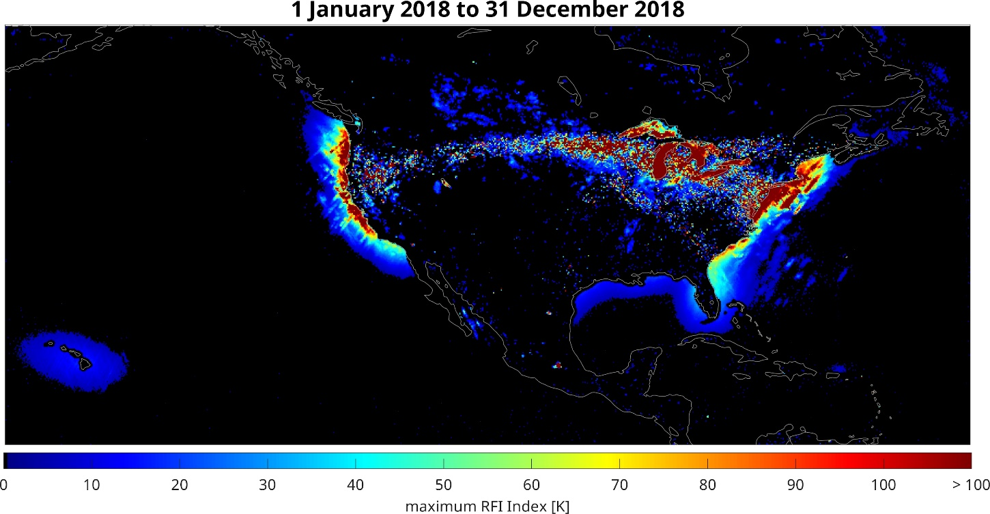
The interference is dependent upon the viewing geometry of the remote sensing sensor. The interference is observed only in particular geometrical configurations: when the EESS satellite is in its ascending part of the orbits and looking backwards (Figure 2, bottom left), or in its descending part of the orbit and looking forward (Figure 2, top right). In both geometrical configurations the satellite is in the northern hemisphere and looking south. It is shown in what follows that the interference may be due to reflection of signals originating from communication satellites.
It should be noted that per Recommendation ITU-R RS.1449, recommends 1, and for evaluation of potential interference into the EESS (passive sensors) in the 18.6-18.8 GHz band from GSO satellites operating in the FSS, the sensor acquiring data over land masses is recommended to be designed to collect data in 50% of its orbit (while travelling towards the poles), in order for the FSS pfd limit, contained in RR Table 21-4, to allow passive sensor to acquire a satisfactory amount of useful data over land masses. Figures 1, 2 and 4 show maps of RFI index over both the land masses and water surfaces, using 100% of the orbit. This document studies the interference over water surface, not considered in Recommendation ITU-R RS.1449.
Figure 2
Maps of the RFI index (i.e., increase of the measured antenna temperature due to RFI contamination)
for different viewing directions. Left column: ascending passes; Right column: descending passes;
Top row: forward looks; Bottom row: aft looks
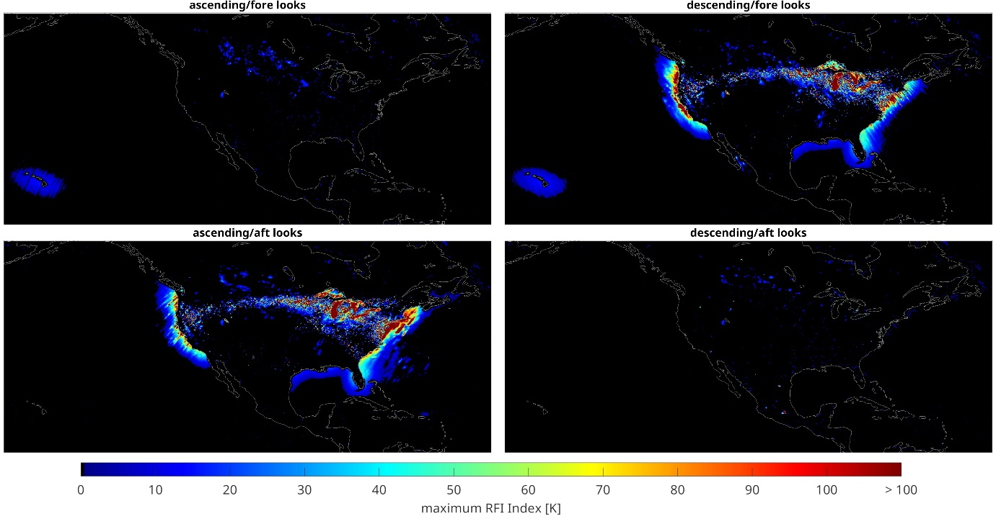
Satellite orbital information and geometry was used to trace the reflected signal to FSS systems in geosynchronous orbit. By projecting the interference levels through a reflection from the ocean out to the geosynchronous sphere, the source of the interference was traced to positions of operational FSS satellites.
The locations of potential interference sources are found by projecting the line of sight of GMI, the receiving satellite into the geosynchronous sphere through a specular reflection from the Earth surface.
A brief mathematical description of the procedure is provided below. The geometry used in the calculation is illustrated in Figure 3. A normal vector $\hat{n}$ and a tangent vector $\hat{τ}$ are defined at the measurement location $r_{m}$ on the Earth surface.
The unit vector ${\hat{ρ}}_{g}$ identifies the path of a potential signal from the satellite glint location $r_{g}$. The satellite glint location is defined as the position on the geosynchronous sphere in line with the reflected line-of-sight of the receiving system, and is written as:
${\hat{ρ}}_{g} =\left({\hat{ρ}}_{g}∙\hat{n}\right) \hat{n}+\left({\hat{ρ}}_{g}∙\hat{τ}\right) \hat{τ }$ = $-\sin{θ_{ }} \hat{n}+\cos{θ_{ }} \hat{τ}$
where $θ$ is the Earth incidence angle of the receiving system. Similarly, the path of the signal travelling from the measurement point $r_{m}$towards the position $r_{rx}$of the satellite receiving interference is described by the unit vector ${\hat{ρ}}_{rx}$ as follows:
${\hat{ρ}}_{rx} =\left({\hat{ρ}}_{rx}∙\hat{n}\right) \hat{n}+\left({\hat{ρ}}_{rx}∙\hat{τ}\right) \hat{τ}$ = $\sin{θ_{ }} \hat{n}+\cos{θ_{ }} \hat{τ}$
Figure 3
The position of a potentially interfering satellite is identified by projecting the line-of-sight of the receiving antenna through a specular reflection from the earth surface to the geosynchronous orbital distance
$${θ_{g}}_{ }$$
$$r_{g}$$
$$r_{rx}$$
$$r_{tx}$$
$${\hat{ρ}}_{g}$$
$${\hat{ρ}}_{tx}$$
$${\hat{ρ}}_{rx}$$
$${\hat{n}}_{ }$$
$${\hat{τ}}_{ }$$
$$r_{m}$$
R
(0,0)
geosynchronous glint location
transmitting system
$${θ_{ }}_{ }$$
$${θ_{ }}_{ }$$
receiving system
If a transmitting system $r_{tx}$is positioned at or near $r_{g}$, then there could be interference of that system with the receiving system. The satellite glint angle is defined as the angle between the specular-reflected line-of-sight ${\hat{ρ}}_{g}$ and the line-of-sight ${\hat{ρ}}_{tx}$of an actual transmitting satellite:
$θ_{g}=\operatorname{acos}\left({\hat{ρ}}_{g}∙ {\hat{ρ}}_{tx}\right)$
The glint angle is 0º if ${\hat{ρ}}_{tx}={\hat{ρ}}_{g}.$
The satellite glint location (position on the geosynchronous sphere in line with the reflected line of sight of the receiving satellite) is computed using the expression:
$r_{g}=r_{m}-d {\hat{ρ}}_{g}$
where $d$ is the distance between the transmitting system and the measurement point on the ground. This equation can be written using its$n$- and $τ$- components as follows:
$r_{g}=-d \cos{θ_{ }}\hat{τ}+\left(R+d \sin{θ_{ }}\right)\hat{ n}$
with $R$ representing the Earth radius. The distance $d$ is determined by the condition:
$\left\|r_{g}\right\|= D$
where $D=$ 42164 km is the distance to the geosynchronous sphere from the Earth’s center. This identifies the estimated position of a transmitting satellite if interference is observed in the measurement.
The interference level $ΔT_{b}\left[i\right]$ (known as the “RFI Index”) in units of Kelvin is computed as the difference between the brightness temperature of the channel of interest to an estimate of the channel brightness temperature computed from other radiometer channels.
$ΔT_{b}\left[i\right]=T_{b}\left[i\right]-T_{b,est}\left[i\right]$
where $T_{b}\left[i\right]$ is the measured brightness temperature of channel $i$ and $T_{b,est}\left[i\right]$ is the estimated brightness temperature based on a linear combination of the brightness temperatures of other channels and their squares. RFI at 18.7 GHz can be identified to within a sensitivity of ~2 K over the ocean.
The transmitting satellites are identified by mapping the $ΔT_{b}\left[i\right]$ from the Earth measurement location to the corresponding location on the geosynchronous sphere. Large clusters of high RFI index values on the geosynchronous sphere identify the location of interfering satellites.
The top panel of Figure 4 shows a swath of GMI data from 1 July 2018 over the continental United States. The RFI index is over 100 K at low satellite glint angles (middle plot). For all the high RFI index values in Figure 2, the glint angle from the interfering satellite is near zero, meaning that the reflected boresight of the receiving sensor is in the field-of-view of a known transmitting geosynchronous satellite.
To identify all the interfering satellites at 18.7 GHz over the continental United States, the methods presented here were applied over 3 months of GMI data. The peak interference for each position on the geosynchronous sphere was identified and plotted in Figure 4. The method locates the longitudes of 12 satellites known to transmit in the 18.7 GHz band. Peak interference levels of over 1 000 K have been observed.
Figure 4
The level of interference originating from the geosynchronous orbit is computed by transferring the map of RFI index (top figure) onto the location of the reflected line-of-sight for the receive antenna at the geosynchronous sphere (bottom). The middle figure shows the geosynchronous satellite glint angle, which is the angle between
the reflected receive antenna line-of-sight and the transmitting antenna line-of-sight.
A lower glint angle suggests a higher likelihood of interference
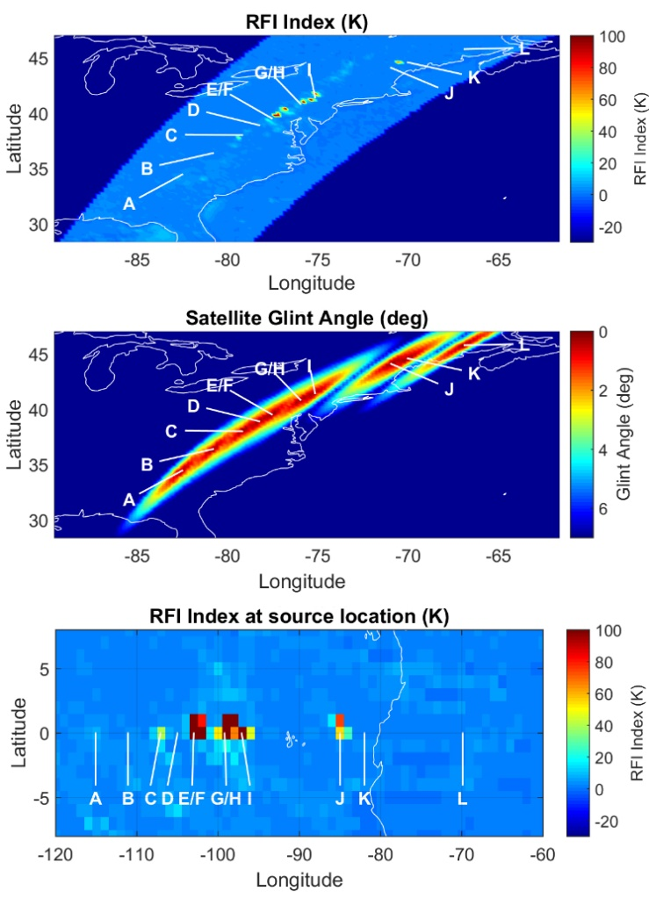
Figure 5, produced from 2018 data, shows the source of the reflected signals, originating from at least twelve different satellites. The letters designated in Figure 5 correspond to known GSO FSS satellite orbital positions, which are listed in Table 2.
Figure 5
Top: 18 GHz V-pol RFI index mapped through Earth reflection to the distance of geosynchronous.
Bottom: Peak RFI index from -1 to +1 latitudes for the same longitudes as top plots. Also listed are the communication satellites with 18 GHz transmitters at the position of the interference source
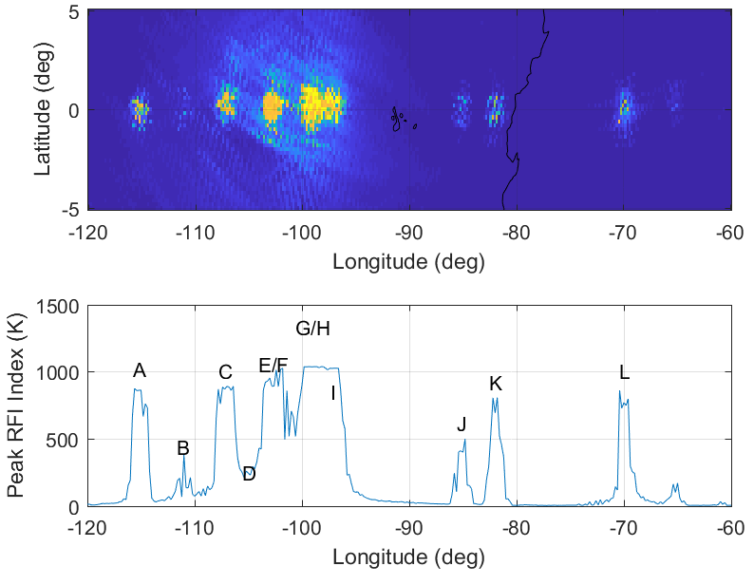
Table 2
GSO satellites positions in Figure 3 {US Question: Should this be Figure 4 and/or Figure 5?}
Letter associated  to FSS satellites | Orbital  position
A | 115.1°W
B | 111.1°W
C | 107.1°W
D | 105.0°W
E and F | 102.8°W
G and H | 99.2°W
I | 97.1°W
J | 85 W
K | 82°W
L | 69.9°W

A measurement area of 10 000 000 km², centred over the Pacific Ocean at 40.0° N 130.5° E, has been selected for an analysis of the fraction of measurements affected by interference. This area is shown in Figure 6 superimposed on a map of the maximum RFI Index for the year 2019.
Figure 6
Measurement area of 10 000 000 km² used for analysis
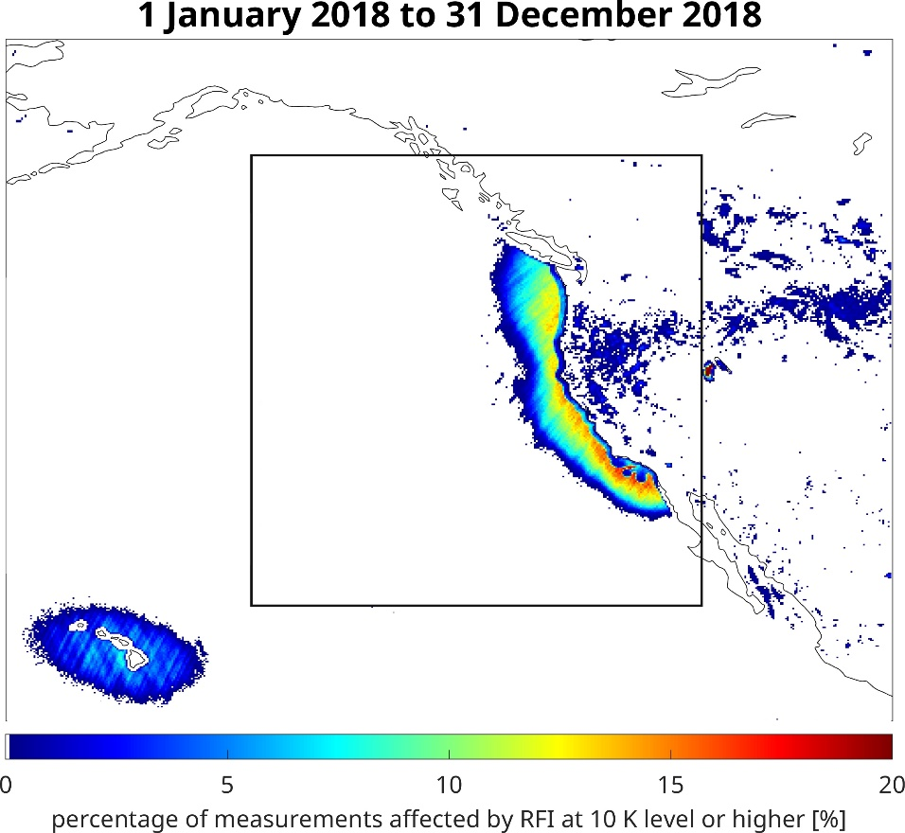
Figure 7 shows the percentage of measurements identified as affected by RFI equal or greater than a certain value in Kelvin (on the x-axis) over the total number of measurements in the square area. Two curves are plotted separately for H- and V-polarization, showing the expected greater impact on H-polarization. All data acquired from 1 January until 31 December 2018, were used to produce this figure.
Figure 7
RFI exceedance in measurement area
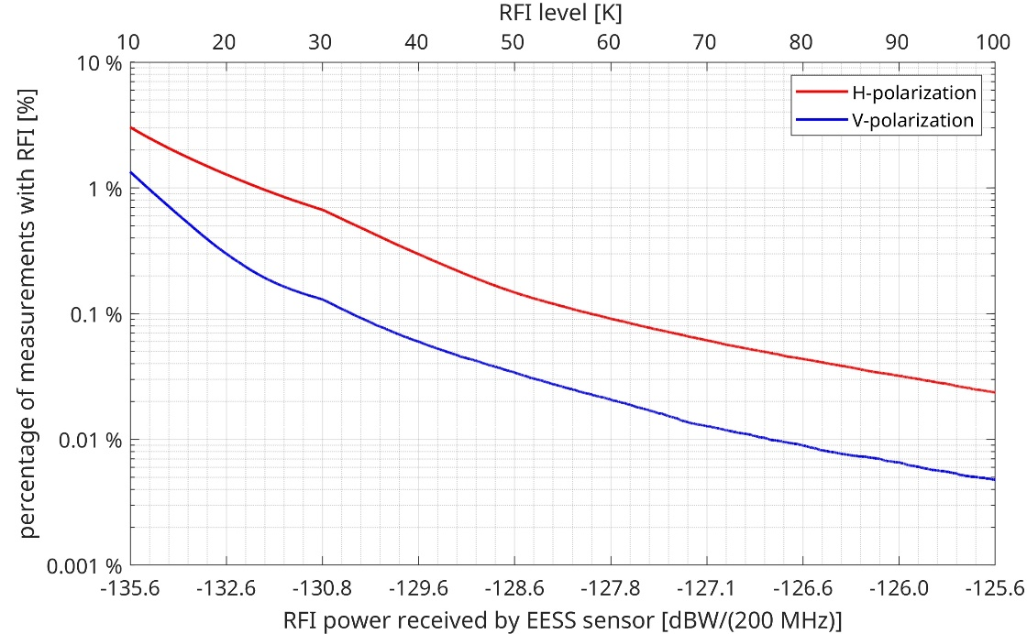
The percentage of interference exceeding 15 K is shown as example in Figure 8 for individual months of the year 2018. The values are listed in Table 3. A 15 K RFI level corresponds to an interference power received by the EESS sensor equal to −133.83 dB(W/(m2 · 200 MHz)).
Figure 8
Monthly values of percentage of measurements with RFI exceeding 15 K for 2018
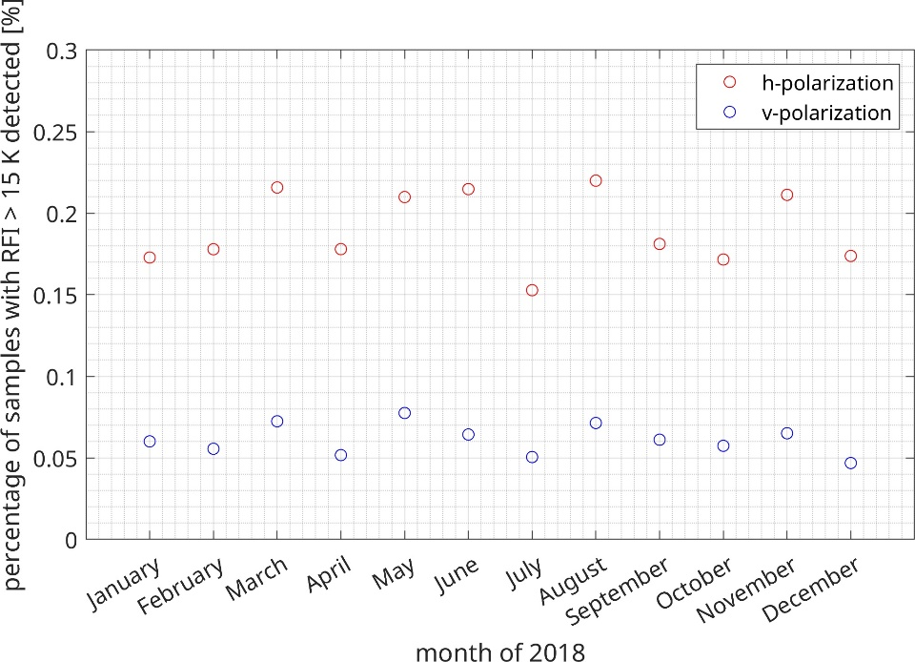
TABLE 3
Monthly values of percentage of measurements with RFI exceeding 15 K for 2018
Month | H-polarization | V-polarization
January | 0.173% | 0.060%
February | 0.178% | 0.056%
March | 0.216% | 0.072%
April | 0.178% | 0.052%
May | 0.210% | 0.077%
June | 0.215% | 0.064%
July | 0.153% | 0.050%
August | 0.220% | 0.071%
September | 0.181% | 0.061%
October | 0.172% | 0.057%
November | 0.211% | 0.065%
December | 0.174% | 0.047%

5 Analysis of potential interference to EESS (passive) caused by FSS emission reflected by ocean surfaces

[5.1 Static analysis
{US Note: This analysis was prepared making use of a draft document under consideration by WP 3J. In 2022, Study Group 3, approved an ITU-R Recommendation pertaining to the sea surface scattering bistatic which is the model that should be used in this study. Consequently, this study should be revised to take into account the approved model in this ITU-R Recommendation.}
{US Note: The United States notes a number of concerns raised with this analysis some of which might not be easily reconcilable. The US consider the dynamic study a more credible analysis, mainly due to matching with the dynamic environment of the scenario as well as the use of appropriate ITU-R model related to scattering bistatic. The US proposes the static study to be removed from the document; alternatively, it should remain within brackets until the the highlighted issues are resolved.}

Since both the EESS (passive) sensor and FSS satellite antennas are Earth-facing, power transmitted by the FSS would enter the EESS (passive) receiver only through the antenna sidelobes if a reflection mechanism did not exist. Since the EESS (passive) sensors are receiving a level of emissions higher than what would be expected from backlobe or sidelobe reception, the assumption is that signals are reflected off the Earth’s surface in the direction of the EESS (passive) sensor. The reflection coefficient models under development in ITU-R Working Party 3J indicate that bodies of water and ice {US Note: RF emission reflection from water is different from the RF emission reflection from ice. 3J did not give any claim about reflection from ice.} have the highest intensity of RF emission reflection {US Note: The propagation model needs to be updated to the model developed in ITU-R P.2146}. As a result, the analyses in this report will examine potential RFI scenarios resulting from reflections off the Earth’s ocean surfaces. An analysis assessing interference to the GPM/GMI EESS (passive) sensor from FSS operations, in-band and adjacent band, is shown below to quantify the effects of these reflected signal paths. The geometry used in this analysis is shown in Figure 9, and Table 4 contains all the relevant geometrical and system parameters as well as the physical constants used in the analysis.
Figure 9
Geometry used in the simulation of RFI to EESS (passive) from FSS GSO
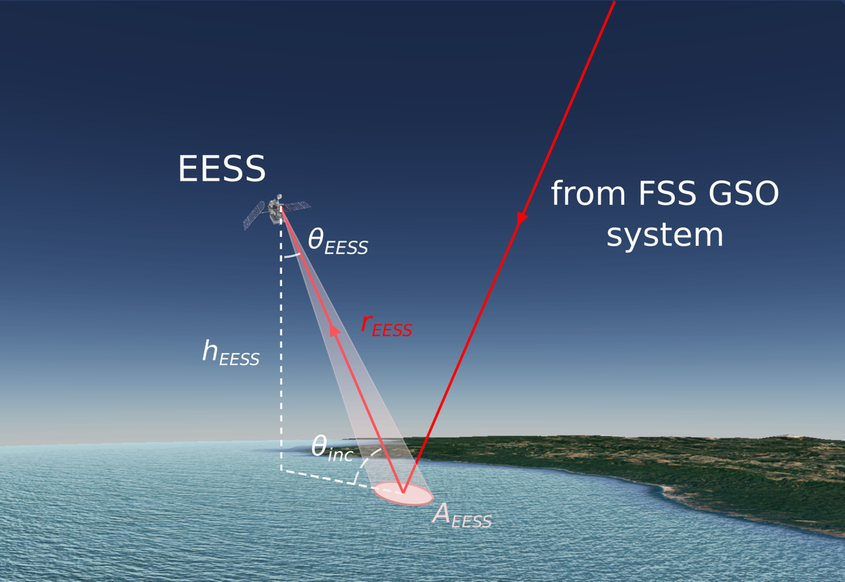

Table 4
Parameters used in the interference analysis
Description | Value | Unit | Variable name
Speed of light | 2.998 × 10⁸ | m/s | c
Boltzmann’s constant | 1.381 × 10⁻²³ | J/K | $$k_{B}$$
Analysis frequency of reflected FSS signal | 18.7 | GHz | f
Earth’s radius | 6 371 | km | $$R_{E}$$
Geostationary satellite altitude | 35 786 | km | $$h_{GEO}$$
GPM/GPI satellite altitude | 407 | km | $$h_{EESS}$$
GPM/GPI nadir look angle | 48.5 | ° | $$θ_{EESS}$$
GPM/GPI antenna diameter | 1.22 | m | $$D_{EESS}$$
GPM/GPI antenna efficiency | 0.65 | – | $$η_{EESS}$$
GPM/GPI footprint size | 18.1 × 10.9 | km $×$ km | $$d_{1}× d_{2}$$

This interference analysis is based on the maximum power flux density from an FSS space station permitted in the 18.6-18.8 GHz frequency band by RR No. 21.16.2, which is $Φ_{FSS}=$ −95 dB(W/(m² · 200 MHz)) as measured at the Earth's surface, except for less than 5% of time, when the limit may be exceeded by up to 3 dB to −92 dB(W/(m² · 200 MHz)). The results computed based on in band FSS transmissions are then extended to out-of-band FSS transmissions by considering that in the 17.7-19.3 GHz frequency range (exclusive of the 18.6-18.8 GHz portion), the RR Table 21-4 permits the maximum power flux density from an FSS space station as measured at the Earth's surface to be −105 dB(W/(m² · 1 MHz)), equivalent to −82 dB(W/(m² · 200 MHz)). In addition, assuming that the effective isotropic radiated power (e.i.r.p.) from FSS satellite operations in the frequency bands adjacent to 18.6-18.8 GHz is to be reduced by the factor OOB_{FSS} = 20 dB {US Question: Is there a source for the 20 dB OOB attenuation?}, resulting into a $Φ_{FSS}=$ −102 dB(W/(m² · 200 MHz)) at 18.7 GHz from these adjacent band FSS operations.
To start, the Law of Sines is used to calculate the Earth's incidence angle {US Note: Based on P. 2146 θinc is measured from the normal to the reflection surface. Figure 9 and the equation for θinc need to be revisted.}:
$θ_{inc}= \sin^{-1}\left(\sin\left(θ_{EESS}\right) ∙ \frac{R_{E}+h_{EESS}}{R_{E}}\right)=52.826°$
and to compute the slant range between the EESS antenna and the reflection area:
$r_{EESS}= R_{E}∙\frac{\sin\left(θ_{inc}-θ_{EESS}\right)}{\sin\left(θ_{EESS}\right)}= 641.618 km$
Assuming an elliptical footprint, the area of the EESS sensor footprint is:
$A_{EESS}=π∙\frac{d_{1}}{2}∙\frac{d_{2}}{2}{=15.495×{10}^{7} m^{2} }$
Assuming a parabolic reflector antenna, the EESS boresight gain for the EESS antenna is given by:
$G_{EESS}= η_{EESS}{\left(\frac{π ∙f ∙D_{EESS}}{c}\right)}^{2}= 37151.347$
or, in dB:
$G_{EESS}[dB]=10\log_{10}\left(G_{EESS}\right)= 45.700 dBi$
Next, the free-space path loss L between the EESS and the reflection area is {US Question: This is equal to krEESS-2. Is this the free space loss or the antenna spreading loss?}:
$L= {\left(\frac{c}{4∙π ∙f ∙r_{EESS}}\right)}^{2}=3.954×{10}^{-18}$
or, in dB:
$L[dB]=10\log_{10}\left(L\right)= -174.024 dB$
The power originating from reflection of the FSS GSO signal on the Earth surface is:
$P_{r}= Φ_{FSS} A_{EESS} σ^{o}$
where$σ^{o}$ is the bistatic scattering coefficient of the Earth surface in the specular direction.
The power received by the EESS sensor is given by:
$P_{EESS}= P_{r}{ L G}_{EESS}= Φ_{FSS} A_{EESS} σ^{o}{ L G}_{EESS}$
or, in dB:
$P_{EESS}\left[dB\right]= Φ_{FSS}\left[dB\right]+{ A}_{EESS}\left[dB\right]+σ^{o}\left[dB\right]+L \left[dB\right]+G_{EESS}[dB]$
The values of the bistatic scattering coefficient $σ^{o}$ over the sea surface depend on the wind speed and can be derived using the model in Document 7C/51 {US Note: The report should ensure the model is based on P.2146 since this essentially supersedes the model in Document 7C/51.}. Figure 10 illustrates the dependence of the bistatic scattering coefficient $σ^{o}$ on the wind speed $U_{10}$ at 10 m above the sea surface.
Figure 10
Bistatic scattering coefficient in the specular direction for wind speed ranging from 1 to 10 m/s {US Question: In the specular direction there are two bistatic scattering coefficient components: Coherent component and diffuse (non-coherent) component. Does Figure 10 account for both components? What is the frequency used in obtaining Figure 10?}
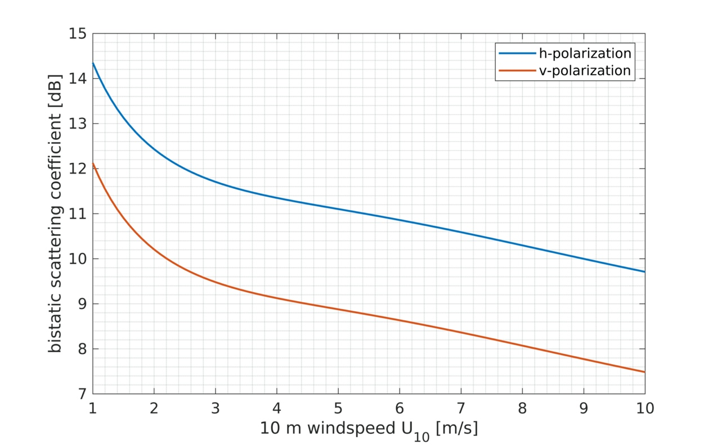
The power $P_{EESS}$ received by the EESS antenna can be computed using these values of the bistatic scattering coefficient $σ^{o}$ and the previous equation, noting that the maximum power flux density from an FSS space station permitted in the 18.6-18.8 GHz frequency band is −95 dB(W/(m² · 200 MHz)) except for less than 5% of time, when the limit may be exceeded by up to 3 dB to −92 dB(W/(m² · 200 MHz)):
Φ_{FSS} [dB] = |  | −95 dB(W/(m² · 200 MHz)) for at least 95% of time
 |  | −92 dB(W/(m² · 200 MHz)) for less than 5% of time

The corresponding plots of $P_{EESS}$ as function of wind speed are given in Figure 11 for the two polarization channels (V and H) of the EESS instrument for FSS power flux density $Φ_{FSS}=$ −95 dB(W/(m² · 200 MHz)). Table 5 lists the received power $P_{EESS}$ due to the FSS GSO transmissions under different wind conditions for the two values of FSS power flux density.
The equivalent brightness temperature corresponding to the received power $P_{EESS}$ can be computed as:
${ T}_{RFI}=\frac{{ P}_{EESS}}{k_{B}B}$
where B = 200 MHz is the bandwidth.
Based on the above results, as an example for the case of wind speed of 3 m/s, the RFI observed by the EESS (passive) would be {US Note: T_{RFI} for the >95% and <5% cases should be double checked. These determined equivalent brightness temperature does not align with the P_{EESS} calculations in Table 5.}:
T_{RFI} = |  | −91.0 K in h polarization | for at least 95% of time
 |  | 54.4 K in v polarization
and
T_{RFI} = |  | 182.0 K in h polarization | for less than 5% of time
 |  | 109.0 K in v polarization
which is slightly below the values being observed by GMI discussed in section 3 {US Note: This conclusion should be re-visited after double checking the T-RFI values above. If this is referencing Figure 4, it would be difficult to relate the numbers to the heat-map without contours.}.
Figure 11
Power $P_{EESS}$ received by the EESS antenna for wind speed ranging from 1 to 10 m/s
for FSS power flux density $Φ_{FSS}=$ −95 dB(W/(m² · 200 MHz))
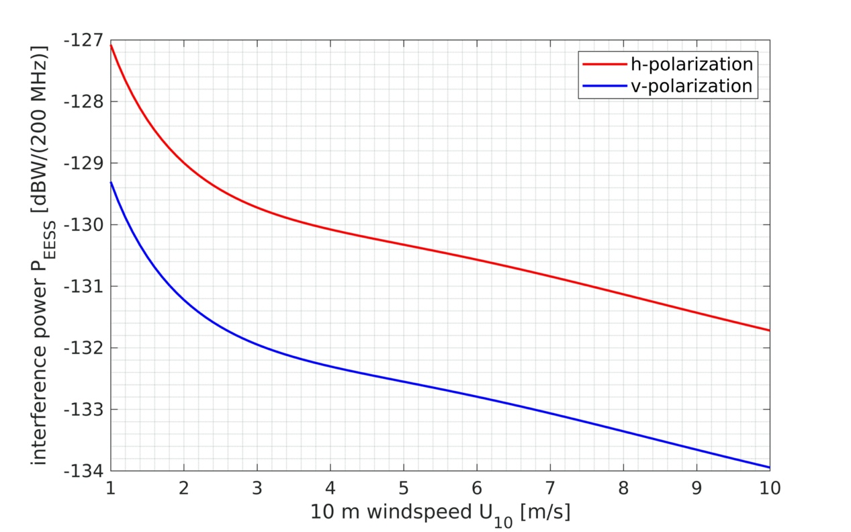
TABLE 5
$P_{EESS}$ due to the FSS GSO transmissions under different wind conditions

[IEEE Note: Remove table above and replace it with Table below] {US Note: The table needs to indicate a 3 dB difference consistently throughout the Table, right column (<5% case) should be greater than the left column (>95% case) by 3 dB. Double check H-Pol and V-Pol P-EESS values for both the >95% and <5% cases.}

U10 [m/s] | h-pol $σ_{0}$  [dB] | v-pol $σ_{0}$  [dB] | h-pol received power  dBW/(200 MHz) |  | v-pol received power  dBW/(200 MHz)
 |  |  | for at least  95% of time | for less than  5% of time | for at least  95% of time | for less than  5% of time
1 | 14.35 | 12.13 | ‒127.08 | ‒124.08 | ‒129.30 | ‒126.30
2 | 12.43 | 10.21 | ‒129.00 | ‒126.00 | ‒131.22 | ‒134.22
3 | 11.71 | 9.48 | ‒129.72 | ‒126.72 | ‒131.95 | ‒134.22
4 | 11.35 | 9.13 | ‒130.08 | ‒127.08 | ‒132.30 | ‒135.30
5 | 11.10 | 8.88 | ‒130.33 | ‒133.33 | ‒132.55 | ‒135.55
6 | 10.86 | 8.63 | ‒130.57 | ‒133.57 | ‒132.79 | ‒135.79
7 | 10.59 | 8.36 | ‒130.84 | ‒133.84 | ‒133.06 | ‒136.06
8 | 10.30 | 8.07 | ‒131.13 | ‒134.13 | ‒133.36 | ‒136.36
9 | 10.00 | 7.77 | ‒131.43 | ‒134.43 | ‒133.66 | ‒136.66
10 | 9.71 | 7.48 | ‒131.72 | ‒134.72 | ‒133.94 | ‒136.94

The results for the case of a single FSS operating in either of the adjacent bands 17.7-18.6 GHz or 18.6-19.3 GHz can be similarly derived by using a power flux density $Φ_{FSS}=$ −102 dB(W/(m² · 200 MHz)) corresponding to the maximum permitted power flux density transmitted in the above bands band attenuated by 20 dB, instead of the maximum pfd value used above. Assuming that the bistatic scattering coefficient computed for 18.7 GHz is the same in the adjacent bands, this is equivalent to subtracting 7 dB, that is, the difference in power flux density between the in-band and out-of-band case to the power $P_{EESS}$ received by the EESS (passive) sensor.
Table 6 summarizes the results for both in-band and out-of-band transmissions in the case of a wind speed of 3 m/s. {US Reason: this consideration is invalid even in a static analysis}
TABLE 6
Summary of reflected in-band and adjacent band FSS emissions {US Note: This should include the bistatic scattering coefficients.}
In-band FSS GSO for 3 m/s wind speed
Center frequency [GHz] | 18.7 | 18.7
Allowable pfd [dB(W/(m² · 200 MHz))] | −95 | −92
Area of EESS (passive) footprint dB(m²) | 81.9 | 81.9
Free-space path loss from Earth surface to EESS [dB] | −174.02 | −174.02
EESS antenna gain [dBi] | 45.70 | 45.70
Reflected power towards EESS at Earth surface [dB(W/200 MHz)] in h-polarization | −1.40 | −1.40
Reflected power towards EESS at Earth surface [dB(W/200 MHz)] in v-polarization | −3.63 | −3.63
Reflected power at EESS [dB(W/200 MHz)] in h-polarization | −129.72 | −126.72
Reflected power at EESS [dB(W/200 MHz)] in v-polarization | −131.95 | −128.95
Out-of-band FSS GSO for 3 m/s wind speed {US reason: it is not described how the static geometry of GSO satellites to the considered area on the surface of the water can be expanded to non-GSO satellites}
Center frequency [GHz] | 18.45 or 19.05 | 18.45 or 19.05
Allowable pfd within the 17.7-18.6 GHz and 18.8-19.3 GHz bands [dB(W/(m² · 200 MHz)) | −82 | −82
Area of EESS (passive) footprint dB(m²) | 81.9 | 81.9
Out of band attenuation [dB] | 20 | 20
Calculated pfd in the 18.6-18.8 GHz band[dB(W/(m² · 200 MHz))] | −102 | −102
Free-space path loss from Earth surface to EESS [dB] | −174.02 | −174.02
EESS antenna gain [dBi] | 45.70 | 45.70
Reflected power towards EESS at Earth surface [dB(W/200 MHz)] in h-polarization | −8.40 | −8.40
Reflected power towards EESS at Earth surface [dB(W/200 MHz)] in v-polarization | −10.63 | −10.63
Reflected power at EESS [dB(W/200 MHz)] in h-polarization | −136.72 | −136.72
Reflected power at EESS [dB(W/200 MHz)] in v-polarization | −138.72 | −138.72

Noise equivalent uncertainties of 0.3 K are expected for sensors such as the EU/ESA Copernicus Imaging Microwave Radiometer system, therefore even RFI levels of only 4.4 K are detrimental to scientific usage, as it is clearly the case in measurements from the GPM/GMI [3].
Given that the protection criteria for the 18.6-18.8 GHz band in Recommendation ITU-R RS.2017 is −163 dB(W/200 MHz) {US Note: Different units relative to Section 5.2.1, recommend to double check units and maintain consistency.}, both situations {US Question: In-band and out-of-band?} have the potential to exceed the EESS (passive) permissible interference threshold. However, this methodology is a static analysis, and it does not consider the dynamic nature of the EESS (passive) sensor as it orbits the Earth. Thus, it does not take into account the percentage of time that the protection criteria may be exceeded, which is 0.1%.
It should also be noted that the EESS (passive) allocation in 18.6-18.8 GHz for Region 1 and 3 was upgraded from secondary to primary at WRC-2000 with the knowledge that the FSS pfd limit of −95 dB(W/m²) per 200 MHz in the 18.6-18.8 GHz band would allow, over land, for up to 17 dB of exceedance of the EESS (passive) protection criteria contained in Recommendation ITU-R SA.1029-1, which has since been superseded by Recommendation ITU-R RS.2017 {US Question: Is there a source of 17 dB exceedance? If there is no source, it is recommended that the computation is verified.}. The 17 dB of exceedance was attributed to scattering from land targets; signal reflections off oceans and other bodies of water/ice were not considered.]

5.2 Dynamic analysis
In order to assess the percentage of a measurement area that would be impacted by such interference due to sea surface reflexion of GSO FSS satellites operating within the band 18.6-18.8 GHz, two simulations were performed. The following subsections describe the assumptions and methodology.

5.2.1 Definition of a reference/measurement area
With regard to EESS (passive) services in the band 18.6-18.8 GHz, the Recommendation ITU-R RS.2017 protection criterion of −163 dB(W/(m² · 200 MHz)) {US Note: Maintain consistent units} not to be exceeded more than 0.1% of the time is associated with a measurement area of 10 000 000 km². This means that only the time events when the EESS sensor footprint is within this measurement area are to be retained for interference calculation and derived statistics.
The measurement areas chosen are square in longitude/latitude and centred over the Pacific at 20° N latitude [IEEE note: longitude is missing] and at 40.0° N 130.5° E.

5.2.2 EESS satellite and sensor
The EESS satellite considered is GPM/GMI, whose 18.6-18.8 GHz channel has the following characteristics (referred to as Sensor D9 in the Recommendation ITU-R RS.1861.
TABLE 7
EESS (passive) parameters {US Question: The supporting text in Section 5.2.4 indicates a high main beam efficiency to mitigate side lobe effects, what efficiency was used?}
Parameter | Value
Sensor type | Conical scan
Orbit parameters
Altitude | 407 km
Inclination | 65°
Sensor antenna parameters
Number of beams | 1
Antenna size | 1.22 m
Maximum beam gain | 45.6 dBi
Polarization | H, V
–3 dB beamwidth | 0.98°
Instantaneous field of view | 18.1 km × 19 km
Off-nadir pointing angle | 48.5°
Incidence angle at Earth | 52.8°
Swath width | 921 km
Antenna efficiency | TBD
Beam dynamics | 32 rpm
Sensor antenna pattern | RS.1813

This is a conically scanning sensor, hence it is rotating around nadir and the combination of this rotation together with the sensor pointing nadir offset angle allows measurements over a large swath with a good resolution, as shown in Figure 12.
The GPM/GMI sensor performs measurements only during a limited portion of its antenna rotation, either during the fore or aft part of the scan. This type of measurement acquisition has been modelled. {US Question: How has it been modelled? What is active ratio that has been used in the modelling?}It can perform measurements in the fore part or in the aft part. The first example of simulation considers only fore-mode acquisitions, while in the second analysis the sensor antenna switches between the two orientations approximately half-way through the time frame under study.
FIGURE 12
Geometry of conical scan passive microwave radiometers
[IEEE note: In the figure above, it is suggested to replace “Geometry of conically scanned microwave” with “Geometry of conically scanning radiometer” or simply remove it (it is already in the figure caption).]

5.2.3 FSS satellite
The GSO FSS satellite considered in the first example is as contained in filing USASAT-70V. The satellite at 99.2° W appears to have a beam pointing towards Hawaii. This allows a comparison of the simulation results obtained with the RFI levels observed over Hawaii on the GPM/GMI sensor.
The required emission parameters are summarized in Table 8.
TABLE 8
GSO FSS parameters
Network | USASAT-70V
Orbital position | 99.2W
Beams | TXLO | TXHI
Maximum satellite antenna gain | 45 dBi | 53 dBi
Minimum power density | −68 dBW/Hz | −76 dBW/Hz
Maximum power density | −58 dBW/Hz | −66 dBW/Hz
Beam pointing | Hawaii
It should be noted that the minimum e.i.r.p. density is the same for both beams. The analysis has been performed using the TXLO beam with the minimum power density.
The second simulation considers the GSO FSS satellite in filing IOMSAT-11A located at at 115.0° W with its spotbeams that point towards the West coast of the continental US. The combined e.i.r.p. for the transmissions in circular right and circular left polarizations are shown in Figure 13.
FIGURE 13
Footprints of e.i.r.p. used for IOMSAT-11A.
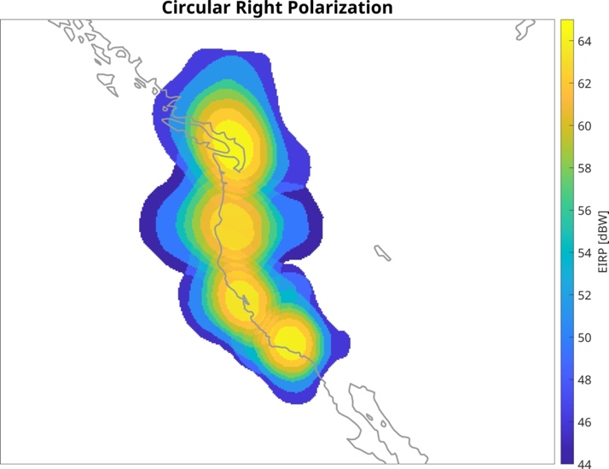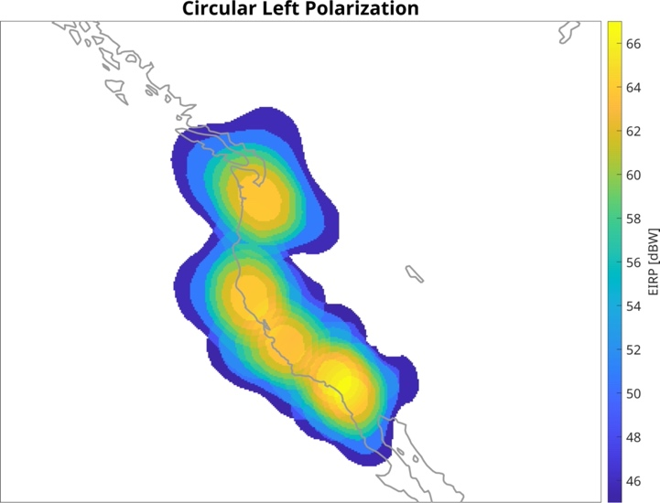

5.2.4 Methodology
The first simulation is performed over 30 days with a 0.1 s time step. In the second simulation, actual GPM/GMI orbital data are used for the period 1-16 August 2019. A sampling time of approximately 15 ms (equal to twice the GPM sampling rate) is employed. The antenna orientation switches from fore to aft on 9 August.
The EESS (passive) satellite uses an on-board antenna with a high main beam efficiency {US Question: What efficiency was used? See Table 7}, which means that the ratio between the energy received through the main beam and the energy received through the side lobes is high. The contribution of interference coming through the EESS sensor sidelobes is therefore neglected and only the sea surface reflection interference events received in the main beam are considered.
The model to estimate the power reflected by the water surface is provided in Recommendation ITU-R P.2146. Related information on ocean surface wind speed is provided by Recommendation ITU-R P.2148.
The scattering is the sum of two components:
– the coherent component, which correspond to the specular reflection, would request for each time step to determine the specular reflection point on the Earth, the distances and antenna gain towards this specular point for both the FSS and EESS satellites;
– the incoherent component, which does not necessarily correspond to specular conditions, is applied over the EESS sensor footprint. In that case the EESS sensor antenna gain is approximated by the maximum antenna gain and the FSS antenna gain is calculated in the direction of the EESS sensor footprint.
At 18 GHz the coherent component is negligible, so only the incoherent component is taken into account. {US Question: Is this referencing Section 8.1 of ITU-R P.2146? If so, this conclusion should be supported by ITU-R P.2146}
The offset angle between the vector FSS-pointing and the vector FSS-EESS footprint is used to calculate the gain of the FSS satellite in the direction of the EESS sensor footprint.
The scattering coefficients $σ_{0}\left({\overset{⃑}{r}}_{t0},{\overset{⃑}{r}}_{r0}\right)$ for the horizontal and vertical polarisations which are received by the EESS sensor are then determined assuming sea salinity of 35 g/kg, and sea water temperature equal to 20° C and 15° C or the simulations over Hawaii and the US West coast, respectively.
The first simulation uses a wind speed of 7 m/s. The analysis over the US West coast uses historical values for 1-16 August 2022, from the ERA5 Copernicus database. Transmissions from the FSS satellite are circularly polarized.
The equation for the incoherent received power can then be simplified to: {US Note: It is Recommend that all variables in equations 1 – 4 are clearly defined}
$P_{nc}≅\frac{P_{t}G_{t}}{{\left(4πr_{t}r_{r}\right)}^{2}}\frac{λ^{2}G_{r0}}{4π}{A σ}_{0,eff}\left({\overset{⃑}{r}}_{t0},{\overset{⃑}{r}}_{r0}\right)$ (1)

where:
$A=\iint{\frac{G_{r}\left({\overset{⃑}{r}}_{r}\right)}{G_{r0}}d\overset{⃑}{ρ}}$ (2)
{US Question: Does “A” in (1) and (2) describe the effective area of the receive antenna? Potential clarification is required between equations [(1) and (2)] and (3).}
is the effective area of the scattered radiation within the footprint of the receive antenna and:
$σ_{0,eff}\left({\overset{⃑}{r}}_{t0},{\overset{⃑}{r}}_{r0}\right)=\frac{1}{A}\iint{σ_{0}\left({\overset{⃑}{r}}_{t},{\overset{⃑}{r}}_{r}\right)\frac{G_{r}\left({\overset{⃑}{r}}_{r}\right)}{G_{r0}}d\overset{⃑}{ρ}}$ (3)
{US Question: Is “A” in (3) the ground footprint area? If so, a different variable definition should be used.}
is the effective NRCS of the integrated area for the centre of the receive beam both toward the transmit antenna ${\overset{⃑}{r}}_{t0}$ and toward the receive antenna ${\overset{⃑}{r}}_{r0}$, and $G_{r0}$ is the peak gain of the antenna.
The area $A$ can be approximated by the projection of area of the 3-dB footprint on the ground $A≅\frac{1}{\cos{θ_{s}}}Ω_{r}R_{r}^{2}$ where $Ω_{r}$ {US Question: Is R_{r} equal to r_{r}? This has to be true for (4) to be true. If this is the case, the variables should be kept consistent.} is the solid angle of the antenna 3-dB pattern and $θ_{s}$ is the Earth incidence angle of the receive antenna. For a high gain receive antenna, the gain of the antenna can be approximated by $G_{r0}≅\frac{4π}{Ω_{r}}$.
Also, for relatively small footprint areas, $σ_{0,eff}\left({\overset{⃑}{r}}_{t0},{\overset{⃑}{r}}_{r0}\right)≅ σ_{0}\left({\overset{⃑}{r}}_{t0},{\overset{⃑}{r}}_{r0}\right).$ With these approximations
$P_{nc}≅\frac{P_{t}G_{t}}{{\left(4πr_{t}r_{r}\right)}^{2}}\frac{λ^{2}}{4π}\frac{4π}{Ω_{r}}\frac{Ω_{r}r_{r}^{2}}{\cos{θ_{s}}}σ_{0}({\overset{⃑}{r}}_{t0},{\overset{⃑}{r}}_{r0})$
$≅\frac{P_{t}G_{t}λ^{2}}{{\left(4πr_{t}\right)}^{2}\cos{θ_{s}}}σ_{0}\left({\overset{⃑}{r}}_{t0},{\overset{⃑}{r}}_{r0}\right)$ (4)
{US Question: Why aren’t the atmospheric losses indicated in the incident and scattered directions, as observed in P.2146? No frequency dependent component is indicated in (4) besides the bistatic scattering coefficient.}

5.2.5 Results
Analysis over Hawaii
As shown in the cdf in Figure 14 for the horizontal polarization, the protection criterion is exceeded by 23 dB when only considering the minimum emission power. The percentage of data loss reaches 5.4%, well above the allowed 0.1%. Note that the maximum interference level is 10 dB lower than the one found in Table 7 due to the fact that only the minimum power density of the FSS filing was considered. When considering the maximum power density, 10 dB above, the results would be similar.
FIGURE 14
Cdf of interference power level {US Question: Include legend in figure to indicate that red ‘+’ is the protection criteria?}
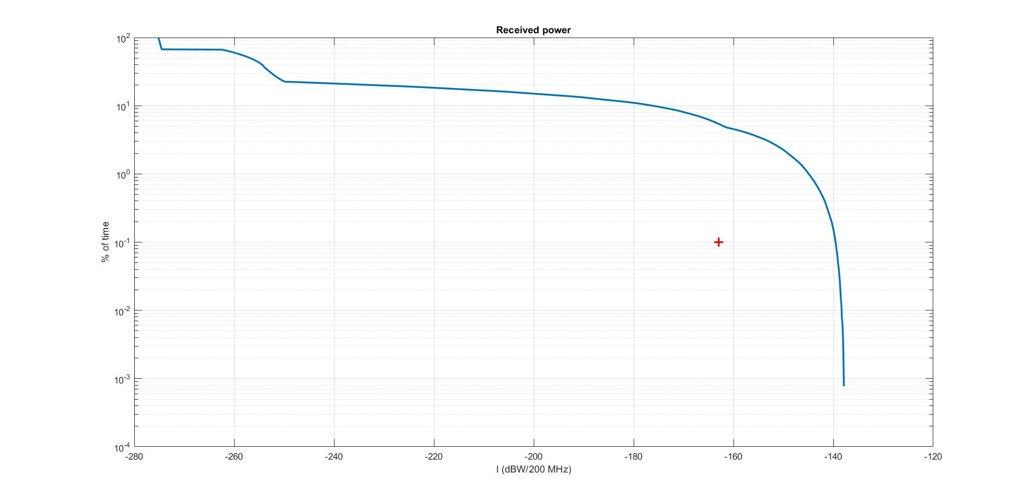
Those interference power levels have been converted into noise temperature to allow for an easy comparison with the RFI observed on this sensor around Hawaii. Figure 15 illustrates in colour the maximum RFI temperature per pixel of 0.5 × 0.5° in longitude and latitude.
FIGURE 15
Map of interference {US Question: include colorbar label to indicate noise temperature, as indicated in the text?}
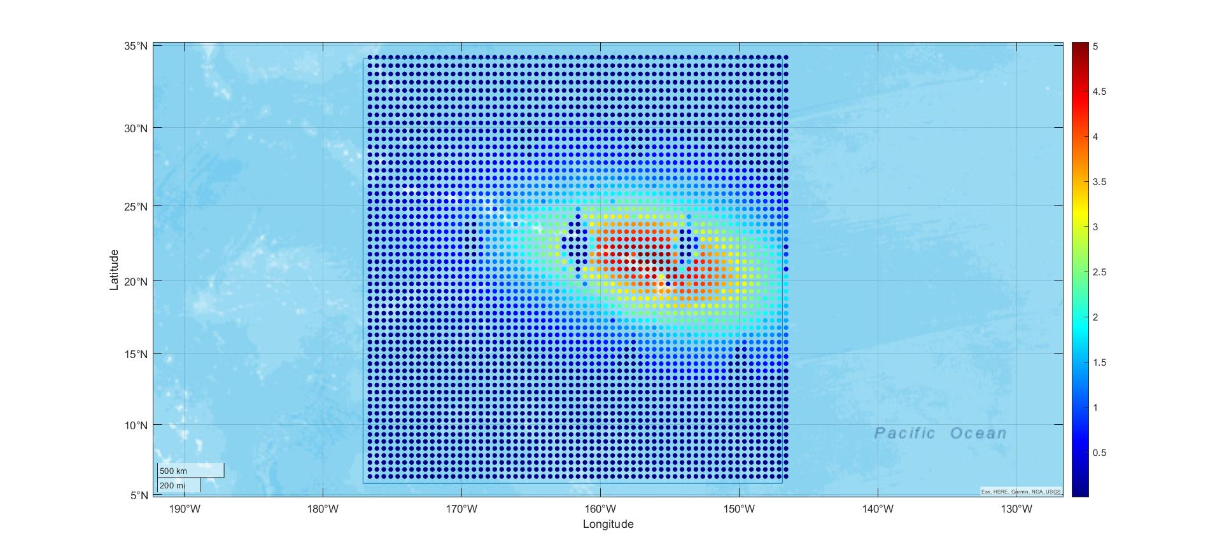
It can be seen that the maximum RFI noise temperature is 5 K {US Question: Is this the true maximum or just the ceiling presented by the colorbar? This might be slightly higher depending on the maximum value displayed in Figure 14.}. When considering the maximum power density (10 dB higher) this would scale to 50 K. The range 5 to 50 K is consistent with the level observed for actual RFI in Figure 1 (turquoise colour around 15 K), noting that the FSS actual emission power is unknown and may vary to compensate for rain attenuation. The two remaining dark blue spots in the coloured shape in the figure would disappear when increasing the simulation duration.
Note that the percentage of data loss is not purely related to the percentage of pixels impacted as the number of time steps where a pixel is impacted varies as well (some pixels may be impacted only once, while other are impacted several times. The cdf should be taken as a reference to determine this percentage of data loss, not the map.
Analysis over the US West coast
Figure 16 depicts the map of interference in V-polarization {US Question: H-Polarization or V-polarization? See the captions below each figure in Figure 16.} in Kelvin (left) and dBW/(200 MHz) (right) obtained with the simulation of the IOMSAT-11A over the US West coast, on a 18 km EASE 2.0 grid.
The maximum RFI level obtained in the analysis is around 12 K at V-polarization and 18 K {US Note: The colorbar is limited at 16 K, the figure should be scaled such that the maximum is 18 K.} at H-polarization, corresponding to −134.8 dB(W/200 MHz) and ‒132.9 dB(W/200 MHz) {US Note: The colorbar for the right figure should be smaller in range and scaled according to the maximum value observed.}, respectively. This exceeds the −163 dB(W/200 MHz) value indicated as maximum allowed interference level under the protection criteria for the 18.6-18.8 GHz band in Recommendation ITU-R RS.2017.
The percentage of measurements affected by interference above a certain value is plotted in Figure 17. The value of RFI that is exceeded is on the x-axis, while y-axis gives the corresponding fraction of measurements corrupted by interference above that level over the total number of measurements collected, expressed as a percent. More than 0.6% of measurements are corrupted by interference above −163 dB(W/200 MHz) {US Note: Figure 17 does not support this conclusion? Figures 16 and 17 indicate that the minimum power received by the sensor is always above -163 dBW/200MHz} while 0.1% of the measurements have RFI above 2.1 K at V-polarization and 3.3 K at H-polarization, corresponding to −142.4 dB(W/200 MHz) and −140.5 dB(W/200 MHz), respectively.
The maximum interference predicted by this analysis is lower than that observed and shown in Figure 1. Some factors could contribute to this difference. One is that several other GSO FSS transmit over the same area considered in the simulation, and the aggregate effect of all transmissions will result in a higher level of interference. In addition, the simulation covers only 16 days (and considered half of the actual GMI samples) compared to one year for the analysis in Figure 1, when varying wind conditions may cause spikes of higher interference.
FIGURE 16
Map of interference at V-polarization for simulation over US West Coast {US Question: H-polarization or V-polarization?}
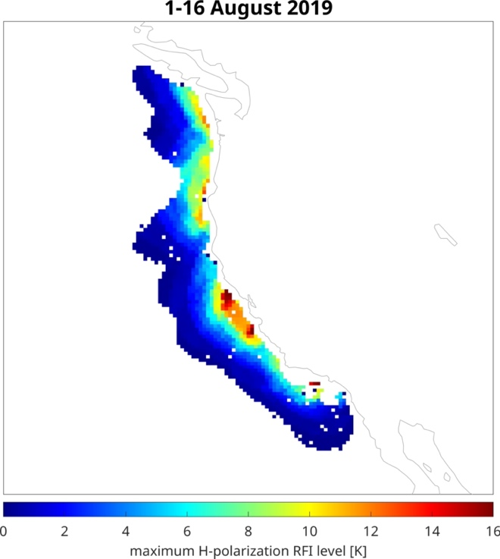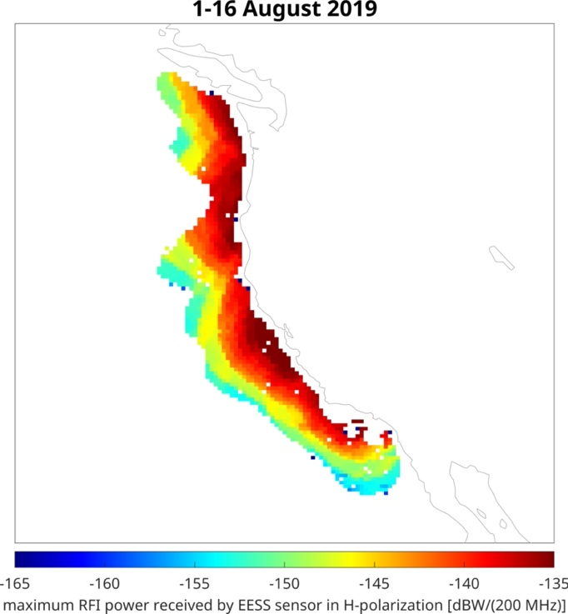
FIGURE 17
Percentage of interference exceedance for simulation over US West Coast
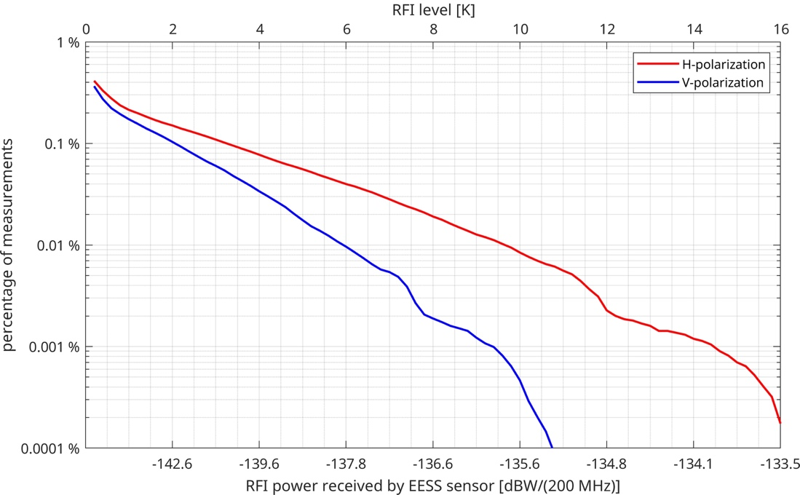

6 Summary
To fully assess the potential for reflected signals into EESS (passive) sensors, it is necessary to understand the relevant specular and diffuse reflection mechanisms for the corresponding frequency band. Further studies are needed to fully validate the exact cause of interference experienced by the EESS (passive) sensors and under what conditions it may occur.
The existing measurements in the 18.6-18.8 GHz frequency band show the increase in brightness temperature from a few Kelvins to more than 1 000 K around coastal areas and large bodies of water. Interference occurring in the range of the level of the sensitivity of the sensor (0.5 K to 1 K) degrades data product accuracy while higher levels of interference occurring in the range of several Kelvins and above renders such data unusable.
However, EESS passive operators in the 18.6-18.8 GHz frequency range have observed interference that have resulted in data loss for several years and the RFI situation appears to be worsening. RFI entering the GPM/GMI receiver due to reflections of FSS GSO and non-GSO space station signals over water surfaces has been estimated assuming that the FSS space station emissions are at the maximum level of −95 dB(W/(m² · 200 MHz)) except for less than 5% of time, when the limit may be exceeded by up to 3 dB to −92 dB(W/(m² · 200 MHz)) produced at the surface of the Earth authorized by RR No. 21.16.2. The results indicate that enough interference would be produced from FSS GSO operations in the 18.6-18.8 GHz band to cause corruption of measurements by the GPM/GMI. However, the predicted levels of RFI are below those observed by the GPM/GMI over some areas (e.g., CONUS coastal areas). Further studies are needed to determine the reason of this discrepancy.

RR No. 21.16.2 provides: “In addition to the limits given in Table 21-4, in the band 18.6-18.8 GHz the sharing environment within which the Earth exploration-satellite (passive) and space research (passive) services shall operate is defined by the following limitations on the operation of the fixed-satellite service: the power flux-density across the 200 MHz band 18.6-18.8 GHz produced at the surface of the Earth by emissions from a space station under assumed free-space propagation conditions shall not exceed −95 dB(W/m²), except for less than 5% of time, when the limit may be exceeded by up to 3 dB. The provisions of No. 21.17 do not apply in this band. (WRC-2000)”.

